Feature Image: See 2025's Top Men’s Diamond Necklace Trends—Explore Now!
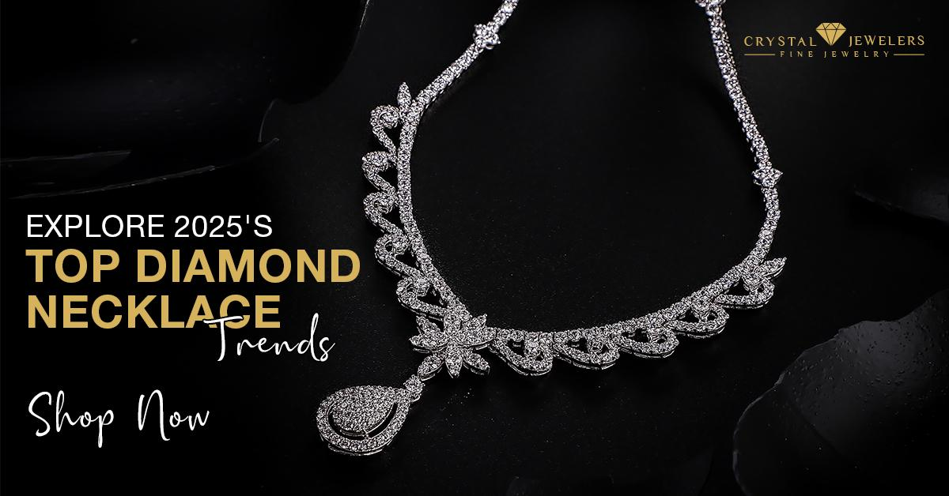

Title: Top Trends in Men’s Diamond Necklaces for 2025
Focus Keyword: diamond necklace for men
Secondary Keyword:
Diamond gold necklace mens
black diamond necklace for men

Internal link:
diamond necklace for men: https://crystaljewelersnc.com/product-category/mens-necklace/
diamond mens wedding bands​: https://crystaljewelersnc.com/product-category/mens-bands/
Meta Description:
Witness the 2025's hottest men's jewelry trends. Geometric designs, Mixed Metals, Simplistic Elegance, and vintage revivals lead the trends.

Top Trends in Men’s Diamond Necklaces for 2025 H1

In 2025, new trends are being adopted in men’s fashion, where diamond necklaces have been perceived to be the hot topic. These ornaments are no longer simply signs of prestige but are rather worn by many people as a symbol of love.
At Crystal Jewelers, we ourselves have been vastly involved in this change and we have a huge collection of diamond necklace for men. So, here is a list of the most important trends for men’s diamond necklaces of the near future.

Simplistic Elegance H2
In 2025, simplicity reigns supreme. Today’s fashion is more inclined towards simple designs. A long neck, single diamond pendant necklace, for instance, is timeless and adopted due to its elegance. These involve round, brilliant cut-shaped necklaces that appear to have simple designs as most of the focus is on the diamond. This is in concord with this trend that is often referred to as less is more.

Example H3
Let us take an example of the Diamond gold necklace mens. This style links the timeless noble metal with a solitary diamond that perhaps the world has never seen before. Such a design is suitable for people who would like to be stylish without excess in any place they are found.

Unique Shapes H2
Round shapes have always been a favorite, in 2025, new shapes of diamonds come into the spotlight. There are now such options as cushion-cut, pear-shaped, and oval. Perhaps these shapes give a new dimension to conventional shapes to give people a new identity.
Example: H3
A black diamond necklace for men can be rather unusual and eye-catching and ,therefore appreciated by men of all cultures. Black diamonds add a certain chic feel to the piece that is quite modern and elegant at the same time.

Mixed Metals H2
Another major style to watch out for is the combination of two metals. The use of gold together with rose gold, silver or even titanium gives the jewelry a modern feeling. This option allows males to try out different colors and make the piece of jewelry somewhat unique to them.

Example H3
A simple piece of jewelry necklace characterized by a gold and silver cycle that has a diamond each. This design is very practical and can be combined with virtually any other outfit and for any occasion.

Layering Options H2
The practice has found much popularity, especially among males that are looking forward to improving the outfits that they wear. Wearing more than one necklace at a given time gives the wear a trendy and unique appearance. It is a trend that calls for rebellion and makes it possible for men to experiment with the designs and lengths.
Example H3
Accessorize a fine and thin strand of diamonds with a less so delicate but heavier piece of jewelry. These two together make it possible to incorporate something that will add interest to the depth of wearer personalities.

Subtle Engravings H2
It may not be a new trend but delicate engraving has increasingly become popular. Depending upon whether the engraving is placed on the wedding anniversary gift, initials, anniversaries or quotes embellished on the jewelry, it provides an intimate touch. This is an excellent way of etching a story on the piece, so every jewelry piece has its story to tell.

Everyday Wearability H3
Diamond necklaces for men in 2025 are perfect for everyday use. The transition from formal to casual wear in daily life gives rise to the need to wear something that withstands the harshness of daily life. The everyday wearable pendants fulfill modern male fashion requirements because they allow daily daytime and evening-night wear.
Example:
A multi-functional diamond gold necklace for the man is ideal for this fashion trend. This beautiful piece can be worn with a simple T-shirt and jeans but also with a business suit and tie if necessary.

Statement Pendants H3
Statement pendants are popular nowadays as they provide a man with an opportunity to have exclusive and unusual accessories. Such pieces are created to be small and come with some additional fine details or a special pattern that can effectively distinguish them from the others. It targets those men who would wish to stand out in the crowd.
Example:
Imagine a piece of necklace that includes a big round diamond in the middle with other small diamonds around it. This design attracts much attention and suits those who like being at the center of attention.

Sustainable Practices H3
The importance of sustainability has been rising in recent years, and this aspect cannot be regarded as unimportant for the jewelry market. It is understood that contemporary masculinity turns to pieces derived from materials that have been produced in an ethical manner. That’s why jewelry stores that follow sustainable practices are getting brighter because consumers are becoming aware of the products they are using.

Personalize Wedding Bands H3
Although it does not constitute a necklace trend, it is worth describing the tendency of applying diamonds into the mens wedding bands. These bands are often incorporating a diamond in the center as it symbolizes the elegance of the whole jewelry item. They are a stylish form of eyewear for individuals who are in search of minimalistic frames.

Customization H3
It has become the trend of the day by giving a man an opportunity to have items of his own choice. Most Jewelry stores provide customization services, which allow clients to pick a diamond shape in addition to materials. The preference for personalized jewelry products provides a convenient solution to those looking for original designs that no other person currently possesses.

Wrap Up H3
While anticipating trends that will be present in 2025, it is very focused on the ideas of customization, universality, and ecological acceptability of the men’s diamond necklaces. Whether it will be characterized by minimalism, geometric forms or eco-friendly material, efforts are made to consolidate the objects that will find their place among modern men.
Crystal Jewelers is keen on embracing such trends to ensure we deal with products that are both classic and unique. If it is the desire of any male individual to go for a diamond gold necklace or if you simply want a statement piece, then there is plenty to offer in our array. Choose the trends and level up your fashion game with an item that fits your personality.
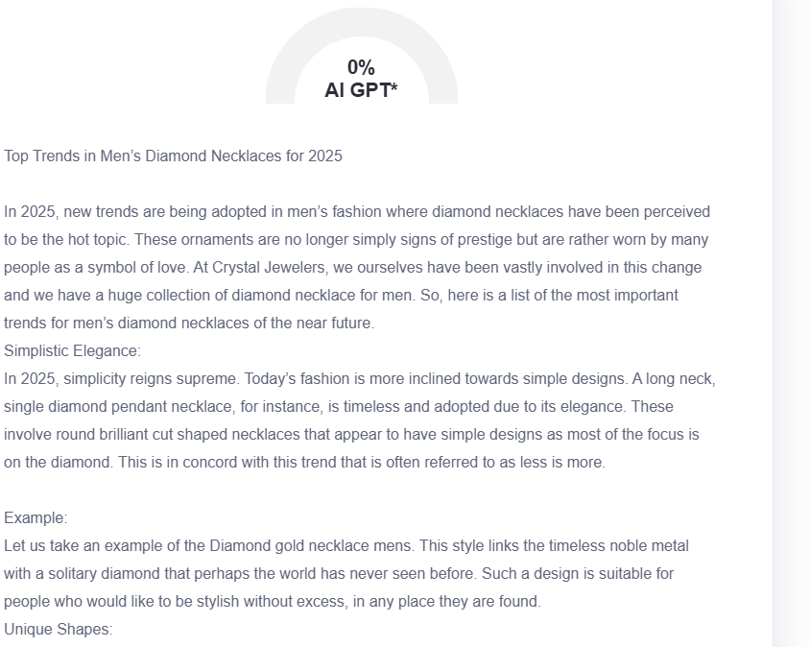

GMB
At Crystal Jewelers, we've watched men's diamond necklaces evolve from subtle accessories to bold style statements. 2025 brings exciting new directions in this growing jewelry category. This year's standout trend? Men choose pendants with geometric designs that include architectural elements. Angular diamond arrangements make men choose triangular, hexagonal and rectangular settings, which fuse attention-getting elements with refined style. Stylish male fashion customers choose black diamonds over classic white stones because they offer a distinctive look. A rebellion of retro-inspired fashion products is now trending among customers. Modern versions of Art Deco design and mid-century structures deliver classic style through innovative contemporary elements. A statement emerges through symmetrical line,s which lead to delicate diamond placements that develop refined radiance. As Greensboro's premier custom jeweler, we're helping men personalize these trends to their unique style. Our expert craftsmen guide clients through selecting the perfect diamond quality, setting style, and metal choice to create necklaces that become signature pieces. Visit Crystal Jewelers to see how these 2025 trends in men's diamond necklaces might enhance your collection. Our curated selection and custom design services ensure you'll find something that resonates with your personal style.

